# **CS 1101-01: Discussion Forum Unit 5**

Godknows Egi

Bachelor of Science in Computer Science, Uopeople

CS 1101-01 - AY2024-T3: Iteration and Strings

Bianca Gilyot

March 5th , 2024

**Discussion Assignment**

For each function, describe what it actually does when called with a string argument. If it does not correctly check for lowercase letters, give an example argument that produces incorrect results, and describe why the result is incorrect.

# 1

def any_lowercase1(s):

     for c in s:

          if c.islower():

               return True

          else:

               return False

# 2

def any_lowercase2(s):

     for c in s:

          if 'c'.islower():

               return 'True'

          else:

               return 'False'

# 3

def any_lowercase3(s):

     for c in s:

          flag = c.islower()

     return flag

# 4

def any_lowercase4(s):

     flag = False

     for c in s:

          flag = flag or c.islower()

     return flag

# 5

def any_lowercase5(s):

     for c in s:

          if not c.islower():

               return False

     return True

**Explanation 1**

# 1

def any_lowercase1(s):

     for c in s:

          if c.islower():

               return True

          else:

               return False

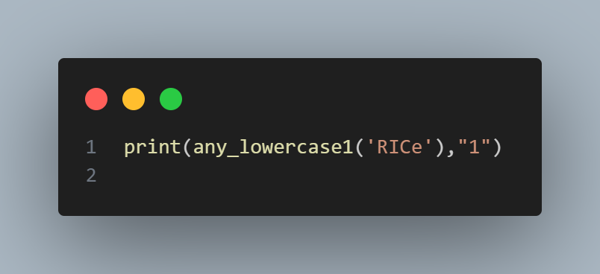

*Code input Figure 1*

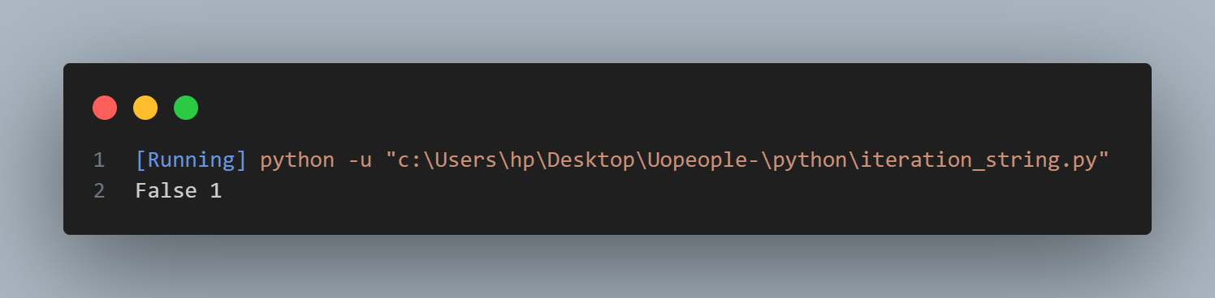

*Code output Figure 1.1*

The first function takes an argument of strings (S), and iterate over them using for loop, In this loop, c represents each character in the string s. So, the if c.islower(): line checks if the current character c is lowercase. If it is, the function immediately returns True because it has found a lowercase character. Otherwise, if the current character is not lowercase, it returns False.

The issue with this approach is that it returns False as soon as it encounters the first character that is not lowercase. This means it doesn't properly check all the characters in the string; it only checks the first character and then returns based on that. This is why it doesn't produce accurate output because it doesn't check all characters as it should.

**Explanation 2**

# 2

def any_lowercase2(s):

     for c in s:

          if 'c'.islower():

               return 'True'

          else:

               return 'False'

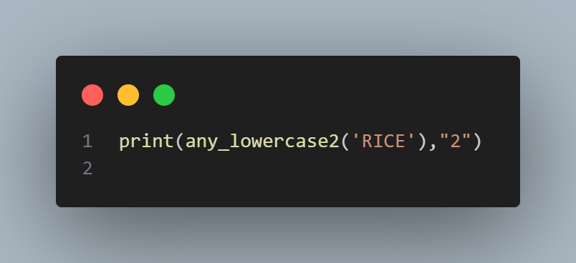

*Code input Figure 2*

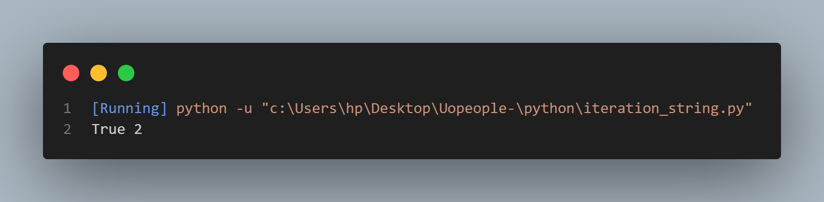

*Code output Figure 2.1*

This function doesn’t correctly check for lowercase arguments due to the if condition is statically checking for the lowercase of “c” string as shown on the question image. This makes the function returns True regardless of what ever value that’s passed as the argument.

**Explanation 3**

# 3

def any_lowercase3(s):

     for c in s:

          flag = c.islower()

     return flag

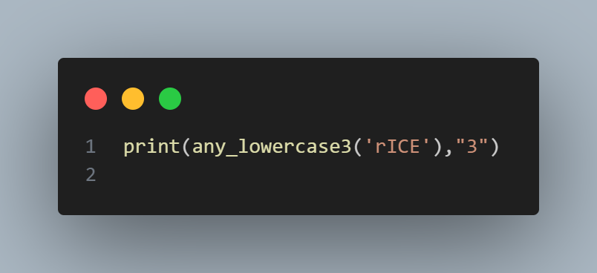

*Code input Figure 3*

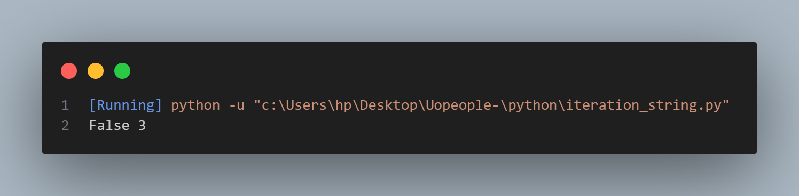

*Code output Figure 3.1*

The error lies in the fact that the flag variable is updated in each iteration of the loop. The loop iterates through each character in the string s, but flag is updated with the lowercase status of each character in the string. Since flag is being updated in each iteration and is not being used outside the loop until the end, it only shows the lowercase status of the last character in the string.

So, when the loop finishes, the function returns the lowercase status of the last character it processed. This means it's not accurately determining whether any character in the string is lowercase; it's just checking the last character.

**Explanation 4**

# 4

def any_lowercase4(s):

     flag = False

     for c in s:

          flag = flag or c.islower()

     return flag

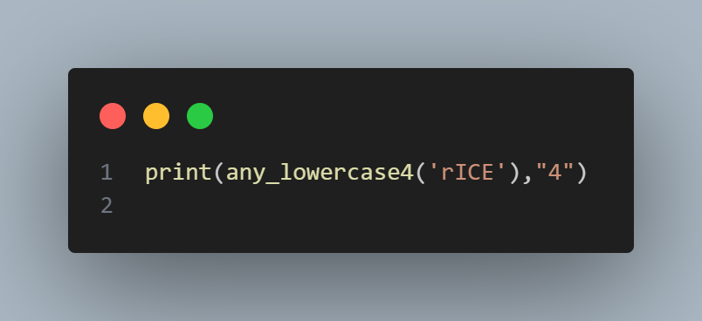

*Code input Figure 4*

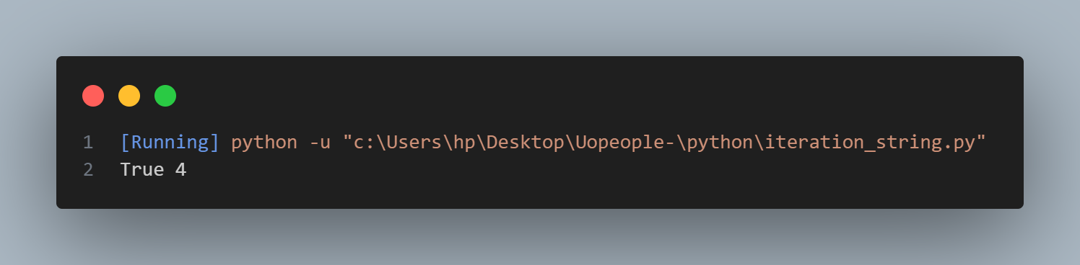

*Code output Figure 4.1*

This function iterates through each character of the string **s** only once. If any lowercase character is found during the iteration, flag variable will be set to True, indicating that at least one lowercase character is present in the string. If no lowercase character is found, flag remains False. This approach makes the function accurately determines whether any character in the string is lowercase.

**Explanation 5**

# 5

def any_lowercase5(s):

     for c in s:

          if not c.islower():

               return False

     return True

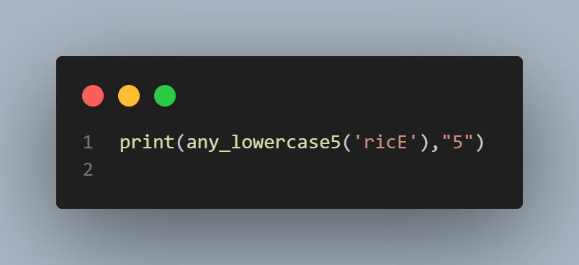

*Code input Figure 5*

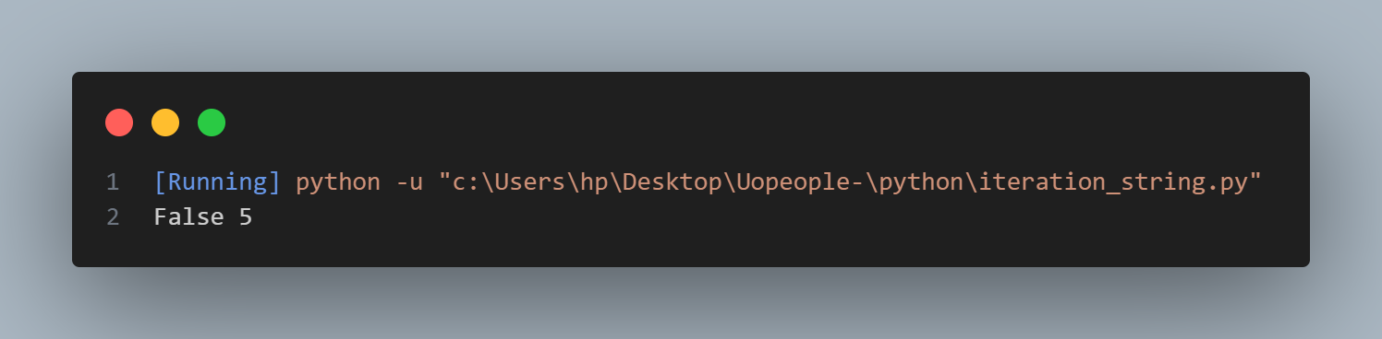

*Code output Figure 5.1*

This function iterates through each character of the string **s** only once. If all the character is found during the iteration that is not lowercase, the function immediately returns False. If the loop completes without finding any such character, it means all characters in the string **s** are lowercase, and the function returns True. I:e it mean for the function to output **True** all the string s most be lowercase, which is not the objective.